**Міністерство освіти і науки України**

**Національний технічний університет України**

**«Київський політехнічний інститут імені Ігоря Сікорського»**

**Факультет інформатики та обчислювальної техніки**

**Кафедра обчислювальної техніки**

**Лабораторна робота №3**

з дисципліни

«Об’єктно орієнтоване програмування»

на тему

“Розробка інтерфейсу користувача на C++”

Виконав: Перевірив:

Студент групи ІМ-22 Порєв В.М.

Кушнір Микола Миколайович

номер у списку групи: 13

Київ 2023

**Мета**

Отримати вміння та навички використовувати інкапсуляцію, абстракцію типів, успадкування та поліморфізм на основі класів С++, запрограмувавши графічний інтерфейс користувача.

**Завдання**

**1.** Створити у середовищі MS Visual Studio C++ проект Win32 з ім’ям **Lab3**.

**2.** Написати вихідний текст програми згідно варіанту завдання.

**3.** Скомпілювати вихідний текст і отримати виконуваний файл програми.

**4.** Перевірити роботу програми. Налагодити програму.

**5.** Проаналізувати та прокоментувати результати та вихідний текст програми.

**6.** Оформити звіт.

**Умови завдання за варіантом (Ж = Жлаб2 + 1 = 13 + 1 = 14):**

* Масив вказівників для динамічних об’єктів типу Shape: статичний масив для Shapeобсягом 114 елементів *(14 mod 3 = 2)*
* "Гумовий" слід при вводі об’єктів: суцільна лінія синього кольору *(14 mod 4 = 2)*
* Увід прямокутника: по двом протилежним кутам *(14 mod 2 = 0)*
* Відображення прямокутника: чорний контур прямокутника без заповнення *(14 mod 5 = 4)*
* Увід еліпса: від центру до одного з кутів охоплюючого прямокутника *(14 mod 2 = 0)*
* Відображення еліпса: чорний контур з кольоровим заповненням *(14 mod 5 = 4)*
* Колір заповнення еліпса: світло-зелений *(14 mod 6 = 2)*
* Позначка поточного типу об’єкту, що вводиться: в меню *(14 mod 2 = 0)*

**Вихідні тексти файлів програми**

**Lab3.kt**

package com.oop.lab3  
  
import android.os.Bundle  
import androidx.appcompat.app.AppCompatActivity

import com.oop.lab3.shape_editor.ShapeObjectsEditor  
import com.oop.lab3.shape.Shape  
import com.oop.lab3.paint_view.PaintView  
import com.oop.lab3.main_toolbar.MainToolbar  
import com.oop.lab3.objects_toolbar.ObjectsToolbar

class Lab3 : AppCompatActivity() {  
 private lateinit var shapeObjEditor: ShapeObjectsEditor  
 private lateinit var mainToolbar: MainToolbar  
 private lateinit var objectsToolbar: ObjectsToolbar

override fun onCreate(savedInstanceState: Bundle?) {  
 super.onCreate(savedInstanceState)  
 setContentView(R.layout.*main_activity*)

shapeObjEditor = ShapeObjectsEditor(this)

mainToolbar = findViewById(R.id.*main_toolbar*)  
 mainToolbar.onCreate(shapeObjEditor)  
 mainToolbar.setObjListeners(::onObjSelect, ::onObjCancel)

objectsToolbar = findViewById(R.id.*objects_toolbar*)  
 objectsToolbar.onCreate(shapeObjEditor)  
 objectsToolbar.setObjListeners(::onObjSelect, ::onObjCancel)

val paintView = findViewById<PaintView>(R.id.*paint_view*)  
 paintView.handler = shapeObjEditor  
 shapeObjEditor.paintUtils = paintView  
 }

private fun onObjSelect(shape: Shape) {  
 mainToolbar.onObjSelect(shape)  
 objectsToolbar.onObjSelect(shape)  
 shapeObjEditor.startEditor(shape)  
 }

private fun onObjCancel() {  
 mainToolbar.onObjCancel()  
 objectsToolbar.onObjCancel()  
 shapeObjEditor.closeEditor()  
 }  
}

**PaintUtils.kt**

package com.oop.lab3.paint_view  
  
import android.graphics.Canvas

interface PaintUtils {  
 val drawnShapesCanvas: Canvas  
 val rubberTraceCanvas: Canvas

fun repaint()  
 fun clearCanvas(canvas: Canvas)  
}

**PaintView.kt**

package com.oop.lab3.paint_view  
  
import android.content.Context  
import android.graphics.Bitmap  
import android.graphics.Canvas  
import android.graphics.Color  
import android.graphics.PorterDuff  
import android.util.AttributeSet  
import android.view.MotionEvent  
import android.view.View

import com.oop.lab3.shape_editor.PaintMessagesHandler

class PaintView(context: Context, attrs: AttributeSet?):  
 View(context, attrs),  
 PaintUtils {  
 lateinit var handler: PaintMessagesHandler

override lateinit var drawnShapesCanvas: Canvas  
 override lateinit var rubberTraceCanvas: Canvas

private lateinit var drawnShapesBitmap: Bitmap  
private lateinit var rubberTraceBitmap: Bitmap

override fun onSizeChanged(w: Int, h: Int, oldw: Int, oldh: Int) {  
 super.onSizeChanged(w, h, oldw, oldh)  
 drawnShapesBitmap = Bitmap.createBitmap(w, h, Bitmap.Config.*ARGB_8888*)  
 drawnShapesCanvas = Canvas(drawnShapesBitmap)  
 rubberTraceBitmap = Bitmap.createBitmap(w, h, Bitmap.Config.*ARGB_8888*)  
 rubberTraceCanvas = Canvas(rubberTraceBitmap)  
}

override fun onDraw(canvas: Canvas) {  
 super.onDraw(canvas)  
 if (!handler.isRubberTraceModeOn) {  
 handler.onPaint()  
 canvas.drawBitmap(drawnShapesBitmap!!, 0F, 0F, null)  
 } else {  
 canvas.drawBitmap(drawnShapesBitmap!!, 0F, 0F, null)  
 canvas.drawBitmap(rubberTraceBitmap!!, 0F, 0F, null)  
 }  
 }

override fun onTouchEvent(event: MotionEvent): Boolean {  
 super.onTouchEvent(event)  
 val x = event.*x* val y = event.*y* when (event.*action*) {  
 MotionEvent.*ACTION_DOWN* -> handler.onFingerTouch(x, y)  
 MotionEvent.*ACTION_MOVE* -> handler.onFingerMove(x, y)  
 MotionEvent.*ACTION_UP* -> handler.onFingerRelease()  
 }  
 return true  
 }

override fun repaint() {  
 invalidate()  
 }

override fun clearCanvas(canvas: Canvas) {  
 canvas.drawColor(Color.*TRANSPARENT*, PorterDuff.Mode.*MULTIPLY*)  
 }  
}

**PaintMessagesHandler.kt**

package com.oop.lab3.shape_editor

interface PaintMessagesHandler {  
 var isRubberTraceModeOn: Boolean

fun onFingerTouch(x: Float, y: Float)  
 fun onFingerMove(x: Float, y:Float)  
 fun onFingerRelease()  
 fun onPaint()  
}

**ShapeObjectsEditor.kt**

package com.oop.lab3.shape_editor  
  
import android.content.Context

import com.oop.lab3.shape.Shape  
import com.oop.lab3.shape.PointShape  
import com.oop.lab3.shape.LineShape  
import com.oop.lab3.shape.RectShape  
import com.oop.lab3.shape.EllipseShape

import com.oop.lab3.editor.ShapeEditor  
import com.oop.lab3.editor.PointShapeEditor  
import com.oop.lab3.editor.LineShapeEditor  
import com.oop.lab3.editor.RectShapeEditor  
import com.oop.lab3.editor.EllipseShapeEditor

import com.oop.lab3.paint_view.PaintUtils

class ShapeObjectsEditor(context: Context): PaintMessagesHandler {  
 lateinit var paintUtils: PaintUtils  
 override var isRubberTraceModeOn = false

val shapes = *arrayOf*(  
 PointShape(context, PointShapeEditor()),  
 LineShape(context, LineShapeEditor()),  
 RectShape(context, RectShapeEditor()),  
 EllipseShape(context, EllipseShapeEditor()),  
 )  
 var currentShape: Shape? = null  
 private set  
 private val drawnShapes = *mutableListOf*<Shape>()  
 private var activeEditor: ShapeEditor? = null

fun startEditor(shape: Shape) {  
 currentShape = shape  
 activeEditor = shape.editor  
 }

fun closeEditor() {  
 currentShape = null  
 activeEditor = null  
 }

override fun onFingerTouch(x: Float, y: Float) {  
 activeEditor?.onFingerTouch(x, y)  
 }

override fun onFingerMove(x: Float, y:Float) {  
 activeEditor?.*let* **{** isRubberTraceModeOn = true  
 paintUtils.clearCanvas(paintUtils.rubberTraceCanvas)  
 **it**.onFingerMove(paintUtils.rubberTraceCanvas, x, y)  
 paintUtils.repaint()  
 **}** }

override fun onFingerRelease() {  
 activeEditor?.*let* **{** isRubberTraceModeOn = false  
 **it**.onFingerRelease(drawnShapes)  
 paintUtils.repaint()  
 **}** }

override fun onPaint() {  
 paintUtils.clearCanvas(paintUtils.rubberTraceCanvas)  
 paintUtils.clearCanvas(paintUtils.drawnShapesCanvas)  
 drawnShapes.*forEach* **{  
 it**.showDefault(paintUtils.drawnShapesCanvas)  
 **}** }

fun undo() {  
 if (drawnShapes.size > 0) {  
 drawnShapes.*removeLast*()  
 paintUtils.repaint()  
 }  
 }

fun clearAll() {  
 if (drawnShapes.size > 0) {  
 drawnShapes.clear()  
 paintUtils.repaint()  
 }  
 }  
}

**Shape.kt**

package com.oop.lab3.shape  
  
import android.content.Context  
import android.graphics.Canvas  
import android.graphics.Paint  
import com.oop.lab3.R

import com.oop.lab3.editor.ShapeEditor

abstract class Shape(private val context: Context) {  
 abstract val name: String  
 val associatedIds = *mutableMapOf*<String, Int>()  
 abstract val editor: ShapeEditor

protected var startX: Float = 0F  
 protected var startY: Float = 0F  
 protected var endX: Float = 0F  
 protected var endY: Float = 0F

fun setStart(x: Float, y: Float) {  
 startX = x  
 startY = y  
 }

fun setEnd(x: Float, y: Float) {  
 endX = x  
 endY = y  
 }

abstract fun isValid(): Boolean

abstract fun getInstance(): Shape

protected open fun getOutlinePaint(): Paint {  
 return Paint().*apply* **{** *isAntiAlias* = true  
 *style* = Paint.Style.*STROKE  
 strokeWidth* = 7F  
 *color* = context.getColor(R.color.*black*)  
 **}** }

protected open fun getFillingPaint(): Paint {  
 return Paint().*apply* **{** *isAntiAlias* = true  
 *style* = Paint.Style.*FILL* **}** }

protected open fun getRubberTracePaint(): Paint {  
 val paint = getOutlinePaint()  
 paint.*color* = context.getColor(R.color.*dark_blue*)  
 return paint  
 }

abstract fun show(canvas: Canvas, outlinePaint: Paint, fillingPaint: Paint?)

abstract fun showDefault(canvas: Canvas)

fun showRubberTrace(canvas: Canvas) {  
 show(canvas, getRubberTracePaint(), null)  
 }  
}

**PointShape.kt**

package com.oop.lab3.shape  
  
import android.content.Context  
import android.graphics.Canvas  
import android.graphics.Paint  
import com.oop.lab3.R

import com.oop.lab3.editor.ShapeEditor

class PointShape(private val context: Context, override val editor: ShapeEditor):  
 Shape(context) {  
 init {  
 editor.shape = this  
 }  
 override val name = context.getString(R.string.*point*)

override fun isValid(): Boolean {  
 return true  
 }

override fun getInstance(): Shape {  
 return PointShape(context, editor).*also* **{  
 it**.associatedIds.putAll(this.associatedIds)  
 **}** }

override fun getOutlinePaint(): Paint {  
 return super.getOutlinePaint().*apply* **{** *strokeWidth* = 15F  
 **}** }  
 override fun getRubberTracePaint(): Paint {  
 return super.getRubberTracePaint().*apply* **{** *strokeWidth* = 15F  
 **}** }

override fun show(canvas: Canvas, outlinePaint: Paint, fillingPaint: Paint?) {  
 canvas.drawPoint(startX, startY, outlinePaint)  
 }

override fun showDefault(canvas: Canvas) {  
 show(canvas, getOutlinePaint(), null)  
 }  
}

**LineShape.kt**

package com.oop.lab3.shape  
  
import android.content.Context  
import android.graphics.Canvas  
import android.graphics.Paint  
import com.oop.lab3.R

import com.oop.lab3.editor.ShapeEditor

class LineShape(private val context: Context, override val editor: ShapeEditor):  
 Shape(context) {  
 init {  
 editor.shape = this  
 }  
 override val name = context.getString(R.string.*line*)

override fun isValid(): Boolean {  
 return (startX != endX || startY != endY)  
 }

override fun getInstance(): Shape {  
 return LineShape(context, editor).*also* **{  
 it**.associatedIds.putAll(this.associatedIds)  
 **}** }

override fun show(canvas: Canvas, outlinePaint: Paint, fillingPaint: Paint?) {  
 canvas.drawLine(startX, startY, endX, endY, outlinePaint)  
 }

override fun showDefault(canvas: Canvas) {  
 show(canvas, getOutlinePaint(), null)  
 }  
}

**RectShape.kt**

package com.oop.lab3.shape  
  
import android.content.Context  
import android.graphics.Canvas  
import android.graphics.Paint  
import android.graphics.RectF  
import com.oop.lab3.R

import com.oop.lab3.editor.ShapeEditor

class RectShape(private val context: Context, override val editor: ShapeEditor):  
 Shape(context) {  
 init {  
 editor.shape = this  
 }  
 override val name = context.getString(R.string.*rectangle*)

override fun isValid(): Boolean {  
 return (startX != endX || startY != endY)  
 }

override fun getInstance(): Shape {  
 return RectShape(context, editor).*also* **{  
 it**.associatedIds.putAll(this.associatedIds)  
 **}** }

override fun show(canvas: Canvas, outlinePaint: Paint, fillingPaint: Paint?) {  
 val rect = RectF(startX, startY, endX, endY)  
 fillingPaint?.*let* **{** canvas.drawRect(rect, **it**)  
 **}** canvas.drawRect(rect, outlinePaint)  
 }

override fun showDefault(canvas: Canvas) {  
 show(canvas, getOutlinePaint(), null)  
 }  
}

**EllipseShape.kt**

package com.oop.lab3.shape  
  
import android.content.Context  
import android.graphics.Canvas  
import android.graphics.Paint  
import android.graphics.RectF  
import com.oop.lab3.R

import com.oop.lab3.editor.ShapeEditor

class EllipseShape(private val context: Context, override val editor: ShapeEditor):  
 Shape(context) {  
 init {  
 editor.shape = this  
 }  
 override val name = context.getString(R.string.*ellipse*)

override fun isValid(): Boolean {  
 return (startX != endX || startY != endY)  
 }

override fun getInstance(): Shape {  
 return EllipseShape(context, editor).*also* **{  
 it**.associatedIds.putAll(this.associatedIds)  
 **}** }

override fun getFillingPaint(): Paint {  
 return super.getFillingPaint().*apply* **{** *color* = context.getColor(R.color.*light_green*)  
 **}** }

override fun show(canvas: Canvas, outlinePaint: Paint, fillingPaint: Paint?) {  
 val rect = RectF(startX, startY, endX, endY)  
 fillingPaint?.*let* **{** canvas.drawOval(rect, **it**)  
 **}** canvas.drawOval(rect, outlinePaint)  
 }

override fun showDefault(canvas: Canvas) {  
 show(canvas, getOutlinePaint(), getFillingPaint())  
 }  
}

**Editor.kt**

package com.oop.lab3.editor  
  
import android.graphics.Canvas

import com.oop.lab2.shape.Shape

abstract class Editor {  
 abstract fun onFingerTouch(x: Float, y: Float)

abstract fun onFingerMove(canvas: Canvas, x: Float, y: Float)

abstract fun onFingerRelease(drawnShapes: MutableList<Shape>)  
}

**ShapeEditor.kt**

package com.oop.lab3.editor  
  
import com.oop.lab2.shape.Shape

abstract class ShapeEditor: Editor() {  
 lateinit var shape: Shape

override fun onFingerRelease(drawnShapes: MutableList<Shape>) {  
 if (shape.isValid()) {  
 drawnShapes.add(shape)  
 }  
 shape = shape.getInstance()  
 }  
}

**PointShapeEditor.kt**

package com.oop.lab3.editor  
  
import android.graphics.Canvas

class PointShapeEditor: ShapeEditor() {  
 override fun onFingerTouch(x: Float, y: Float) {  
 shape.setStart(x, y)  
 }

override fun onFingerMove(canvas: Canvas, paint: Paint, x: Float, y: Float) {  
 shape.showRubberTrace(canvas)  
 }  
}

**LineShapeEditor.kt**

package com.oop.lab3.editor  
  
import android.graphics.Canvas

class LineShapeEditor: ShapeEditor() {  
 override fun onFingerTouch(x: Float, y: Float) {  
 shape.setStart(x, y)

shape.setEnd(x, y)  
 }

override fun onFingerMove(canvas: Canvas, paint: Paint, x: Float, y: Float) {  
 shape.setEnd(x, y)  
 shape.showRubberTrace(canvas)  
 }  
}

**RectShapeEditor.kt**

package com.oop.lab3.editor  
  
import android.graphics.Canvas

class RectShapeEditor: ShapeEditor() {  
 override fun onFingerTouch(x: Float, y: Float) {  
 shape.setStart(x, y)  
 shape.setEnd(x, y)  
 }

override fun onFingerMove(canvas: Canvas, paint: Paint, x: Float, y: Float) {  
 shape.setEnd(x, y)  
 shape.showRubberTrace(canvas)  
 }  
}

**EllipseShapeEditor.kt**

package com.oop.lab3.editor  
  
import android.graphics.Canvas  
import android.graphics.PointF  
import android.graphics.RectF

class EllipseShapeEditor : ShapeEditor() {  
 private val shapeCenterPoint = PointF()

override fun onFingerTouch(x: Float, y: Float) {  
 shapeCenterPoint.set(x, y)  
 shape.setStart(x, y)  
 shape.setEnd(x, y)  
 }

override fun onFingerMove(canvas: Canvas, x: Float, y: Float) {  
 val dx = x - shapeCenterPoint.x  
 val oppositeX = shapeCenterPoint.x - dx  
 val dy = y - shapeCenterPoint.y  
 val oppositeY = shapeCenterPoint.y - dy  
 val enclosingRect = RectF(oppositeX, oppositeY - dy, x, y).*apply* **{** sort() **}** shape.setStart(enclosingRect.left, enclosingRect.top)  
 shape.setEnd(enclosingRect.right, enclosingRect.bottom)  
 shape.showRubberTrace(canvas)  
 }  
}

**MainToolbar.kt**

package com.oop.lab3.main_toolbar  
  
import android.content.Context  
import android.util.AttributeSet  
import android.view.MenuItem  
import android.view.View  
import android.widget.ImageButton  
import android.widget.PopupMenu  
import android.widget.TextView  
import androidx.appcompat.widget.Toolbar  
import com.oop.lab3.R

import com.oop.lab3.shape_editor.ShapeObjectsEditor  
import com.oop.lab3.shape.Shape  
import com.oop.lab3.tooltip.Tooltip

class MainToolbar(context: Context, attrs: AttributeSet?):  
 Toolbar(context, attrs) {  
 private lateinit var optionsMenu: PopupMenu  
 private lateinit var fileSubmenu: PopupMenu  
 private lateinit var objSubmenu: PopupMenu

private lateinit var shapeObjEditor: ShapeObjectsEditor  
 private lateinit var objSubmenuItems: Array<MenuItem>

private lateinit var onObjSelectListener: (Shape) -> Unit  
 private lateinit var onObjCancelListener: () -> Unit

private lateinit var currentObjTextView: TextView

fun onCreate(shapeObjEditor: ShapeObjectsEditor) {  
 val btnOptions = findViewById<ImageButton>(R.id.*btn_options*)  
 btnOptions.setOnClickListener **{** optionsMenu.show()  
 **}** optionsMenu = createOptionsMenu(btnOptions)  
 fileSubmenu = createFileSubmenu(btnOptions)  
 objSubmenu = createObjSubmenu(btnOptions)  
 this.shapeObjEditor = shapeObjEditor  
 objSubmenuItems = *arrayOf*(  
 objSubmenu.*menu*.findItem(R.id.*item_point*),  
 objSubmenu.*menu*.findItem(R.id.*item_line*),  
 objSubmenu.*menu*.findItem(R.id.*item_rectangle*),  
 objSubmenu.*menu*.findItem(R.id.*item_ellipse*),  
 )  
 for (index in objSubmenuItems.*indices*) {  
 val shape = shapeObjEditor.shapes[index]  
 val item = objSubmenuItems[index]  
 shape.associatedIds["objSubmenuItem"] = item.*itemId* }  
 currentObjTextView = findViewById(R.id.*current_object*)  
 }

private fun createOptionsMenu(anchor: View): PopupMenu {  
 val popupMenu = PopupMenu(*context*, anchor)  
 popupMenu.*menuInflater*.inflate(R.menu.*main_toolbar_options_menu*, popupMenu.*menu*)  
 popupMenu.setOnMenuItemClickListener **{** item **->** when(item.*itemId*) {  
 R.id.*file* -> {  
 fileSubmenu.show()  
 true  
 }  
 R.id.*objects* -> {  
 objSubmenu.show()  
 true  
 }  
 R.id.*info* -> {  
 val tooltip = Tooltip(*context*, attrs = null)  
 val text = "Ви натиснули кнопку\n\"Довідка\""  
 tooltip.create(this, text).show()  
 true  
 }  
 else -> {  
 false  
 }  
 }  
 **}** return popupMenu  
 }

private fun createFileSubmenu(anchor: View): PopupMenu {  
 val popupMenu = PopupMenu(*context*, anchor)  
 popupMenu.*menuInflater*.inflate(R.menu.*main_toolbar_file_submenu*, popupMenu.*menu*)  
 popupMenu.setOnMenuItemClickListener **{** item **->** when(item.*itemId*) {  
 R.id.*undo* -> {  
 shapeObjEditor.undo()  
 true  
 }  
 R.id.*clear_all* -> {  
 shapeObjEditor.clearAll()  
 true  
 }  
 else -> {  
 false  
 }  
 }  
 **}** return popupMenu  
 }

private fun createObjSubmenu(anchor: View): PopupMenu {  
 val popupMenu = PopupMenu(*context*, anchor)  
 popupMenu.*menuInflater*.inflate(R.menu.*main_toolbar_objects_submenu*, popupMenu.*menu*)  
 popupMenu.setOnMenuItemClickListener **{** clickedItem **->** for (index in objSubmenuItems.*indices*) {  
 val item = objSubmenuItems[index]  
 if (item == clickedItem) {  
 if (!item.*isChecked*) {  
 val shape = shapeObjEditor.shapes[index]  
 onObjSelectListener(shape.getInstance())  
 } else {  
 onObjCancelListener()  
 }  
 }  
 }  
 true  
 **}** return popupMenu  
 }

fun setObjListeners(  
 onSelectListener: (Shape) -> Unit,  
 onCancelListener: () -> Unit  
 ) {  
 onObjSelectListener = onSelectListener  
 onObjCancelListener = onCancelListener  
 }

fun onObjSelect(shape: Shape) {  
 currentObjTextView.*text* = shape.name  
 shapeObjEditor.currentShape?.*let* **{** val id = **it**.associatedIds["objSubmenuItem"]  
 val item = objSubmenu.*menu*.findItem(id!!)  
 item.*isChecked* = false  
 **}** val id = shape.associatedIds["objSubmenuItem"]  
 val item = objSubmenu.*menu*.findItem(id!!)  
 item.*isChecked* = true  
 }

fun onObjCancel() {  
 currentObjTextView.*text* = "Не вибрано"  
 shapeObjEditor.currentShape?.*let* **{** val id = **it**.associatedIds["objSubmenuItem"]  
 val item = objSubmenu.*menu*.findItem(id!!)  
 item.*isChecked* = false  
 **}** }  
}

**ObjectsToolbar.kt**

package com.oop.lab3.objects_toolbar  
  
import android.content.Context  
import android.util.AttributeSet  
import androidx.appcompat.widget.Toolbar  
import com.oop.lab3.R

import com.oop.lab3.shape_editor.ShapeObjectsEditor  
import com.oop.lab3.shape.Shape

class ObjectsToolbar(context: Context, attrs: AttributeSet?):  
 Toolbar(context, attrs) {  
 private lateinit var shapeObjEditor: ShapeObjectsEditor  
 private lateinit var objButtons: Array<ObjectButton>

private lateinit var onObjSelectListener: (Shape) -> Unit  
 private lateinit var onObjCancelListener: () -> Unit

fun onCreate(shapeObjEditor: ShapeObjectsEditor) {  
 this.shapeObjEditor = shapeObjEditor  
 objButtons = *arrayOf*(  
 findViewById(R.id.*btn_point*),  
 findViewById(R.id.*btn_line*),  
 findViewById(R.id.*btn_rectangle*),  
 findViewById(R.id.*btn_ellipse*),  
 )  
 for (index in objButtons.*indices*) {  
 val shape = shapeObjEditor.shapes[index]  
 val button = objButtons[index]  
 shape.associatedIds["objButton"] = button.*id* }  
 }

fun setObjListeners(  
 onSelectListener: (Shape) -> Unit,  
 onCancelListener: () -> Unit  
 ) {  
 onObjSelectListener = onSelectListener  
 onObjCancelListener = onCancelListener  
  
 for (index in objButtons.*indices*) {  
 val button = objButtons[index]  
 val shape = shapeObjEditor.shapes[index]  
 button.onCreate(shape)  
 button.setObjListeners(onObjSelectListener, onObjCancelListener)  
 }  
 }

fun onObjSelect(shape: Shape) {  
 shapeObjEditor.currentShape?.*let* **{** val id = **it**.associatedIds["objButton"]  
 val button = findViewById<ObjectButton>(id!!)  
 button.onObjCancel()  
 **}** val id = shape.associatedIds["objButton"]  
 val button = findViewById<ObjectButton>(id!!)  
 button.onObjSelect()  
 }

fun onObjCancel() {  
 shapeObjEditor.currentShape?.*let* **{** val id = **it**.associatedIds["objButton"]  
 val button = findViewById<ObjectButton>(id!!)  
 button.onObjCancel()  
 **}** }  
}

**ObjectButton.kt**

package com.oop.lab3.objects_toolbar  
  
import android.content.Context  
import android.graphics.PorterDuff  
import android.graphics.PorterDuffColorFilter  
import android.util.AttributeSet  
import android.view.MotionEvent  
import com.oop.lab3.R

import com.oop.lab3.shape.Shape  
import com.oop.lab3.tooltip.Tooltip

class ObjectButton(context: Context, attrs: AttributeSet?):  
 androidx.appcompat.widget.AppCompatImageButton(context, attrs) {  
 private lateinit var shape: Shape

private var isObjSelected = false  
 private lateinit var onObjSelectListener: (Shape) -> Unit  
 private lateinit var onObjCancelListener: () -> Unit

private val selectTooltip = Tooltip(context, attrs)  
 private val cancelTooltip = Tooltip(context, attrs)

private val timeOfLongPress = 1000  
 private var pressStartTime: Long = 0  
 private var pressEndTime: Long = 0

fun onCreate(shape: Shape) {  
 this.shape = shape  
 val selectTooltipText = "Вибрати об\'єкт\n\"${shape.name}\""  
 selectTooltip.create(this, selectTooltipText)  
 val cancelTooltipText = "Вимкнути режим\nредагування"  
 cancelTooltip.create(this, cancelTooltipText)  
 }

override fun onTouchEvent(event: MotionEvent): Boolean {  
 when (event.*action*) {  
 MotionEvent.*ACTION_DOWN* -> {  
 markPressed()  
 pressStartTime = System.currentTimeMillis()  
 }  
 MotionEvent.*ACTION_UP* -> {  
 pressEndTime = System.currentTimeMillis()  
 val pressDuration = pressEndTime - pressStartTime  
 if (pressDuration < timeOfLongPress) {  
 performClick()  
 } else {  
 performLongClick()  
 }  
 pressStartTime = 0  
 pressEndTime = 0  
 }  
 }  
 return true  
 }

override fun performClick(): Boolean {  
 super.performClick()  
 if (!isObjSelected) {  
 onObjSelectListener(shape.getInstance())  
 } else {  
 onObjCancelListener()  
 }  
 return true  
 }

override fun performLongClick(): Boolean {  
 super.performLongClick()  
 if (!isObjSelected) {  
 markNotPressed()  
 selectTooltip.show()  
 } else {  
 markSelected()  
 cancelTooltip.show()  
 }  
 return true  
 }

private fun markPressed() {  
 val backgroundColorId = R.color.*pressed_btn_background_color  
 backgroundTintList* = *context*.getColorStateList(backgroundColorId)  
 }

private fun markNotPressed() {  
 val backgroundColorId = R.color.*transparent  
 backgroundTintList* = *context*.getColorStateList(backgroundColorId)  
 }

private fun markSelected() {  
 val backgroundColorId = R.color.*selected_btn_background_color  
 backgroundTintList* = *context*.getColorStateList(backgroundColorId)  
 val iconColor = *context*.getColor(R.color.*selected_btn_icon_color*)  
 *colorFilter* = PorterDuffColorFilter(iconColor, PorterDuff.Mode.*SRC_IN*)  
 }

private fun markNotSelected() {  
 val backgroundColorId = R.color.*transparent  
 backgroundTintList* = *context*.getColorStateList(backgroundColorId)  
 val iconColor = *context*.getColor(R.color.*on_objects_toolbar_color*)  
 *colorFilter* = PorterDuffColorFilter(iconColor, PorterDuff.Mode.*SRC_IN*)  
 }

fun setObjListeners(  
 onSelectListener: (Shape) -> Unit,  
 onCancelListener: () -> Unit  
 ) {  
 onObjSelectListener = onSelectListener  
 onObjCancelListener = onCancelListener  
 }

fun onObjSelect() {  
 isObjSelected = true  
 markSelected()  
 }

fun onObjCancel() {  
 isObjSelected = false  
 markNotSelected()  
 }  
}

**Tooltip.kt**

package com.oop.lab3.tooltip  
  
import android.content.Context  
import android.util.AttributeSet  
import android.view.View  
import android.widget.Button  
import android.widget.TextView  
import com.google.android.material.snackbar.Snackbar  
import com.oop.lab3.R

class Tooltip(context: Context, attrs: AttributeSet?): View(context, attrs) {  
 private lateinit var tooltip: Snackbar

fun create(parent: View, text: String): Tooltip {  
 val displayDuration = Snackbar.*LENGTH_LONG* tooltip = Snackbar.make(parent, "", displayDuration)

val backgroundColor = *context*.getColor(R.color.*transparent*)  
 tooltip.*view*.setBackgroundColor(backgroundColor)

val layout = tooltip.*view* as Snackbar.SnackbarLayout  
 val view = inflate(*context*, R.layout.*tooltip*, null)  
 layout.addView(view)

val textView = view.findViewById<TextView>(R.id.*tooltip_text*)  
 textView.*text* = text  
  
 val btnHide = view.findViewById<Button>(R.id.*tooltip_hide*)  
 btnHide.setOnClickListener **{** val textColor = *context*.getColor(R.color.*tooltip_bnt_clicked_text_color*)  
 btnHide.setTextColor(textColor)  
 hide()  
 **}** return this  
 }

fun hide() {  
 tooltip.dismiss()  
 }

fun show() {  
 tooltip.show()  
 }  
}

**Діаграма класів програми**

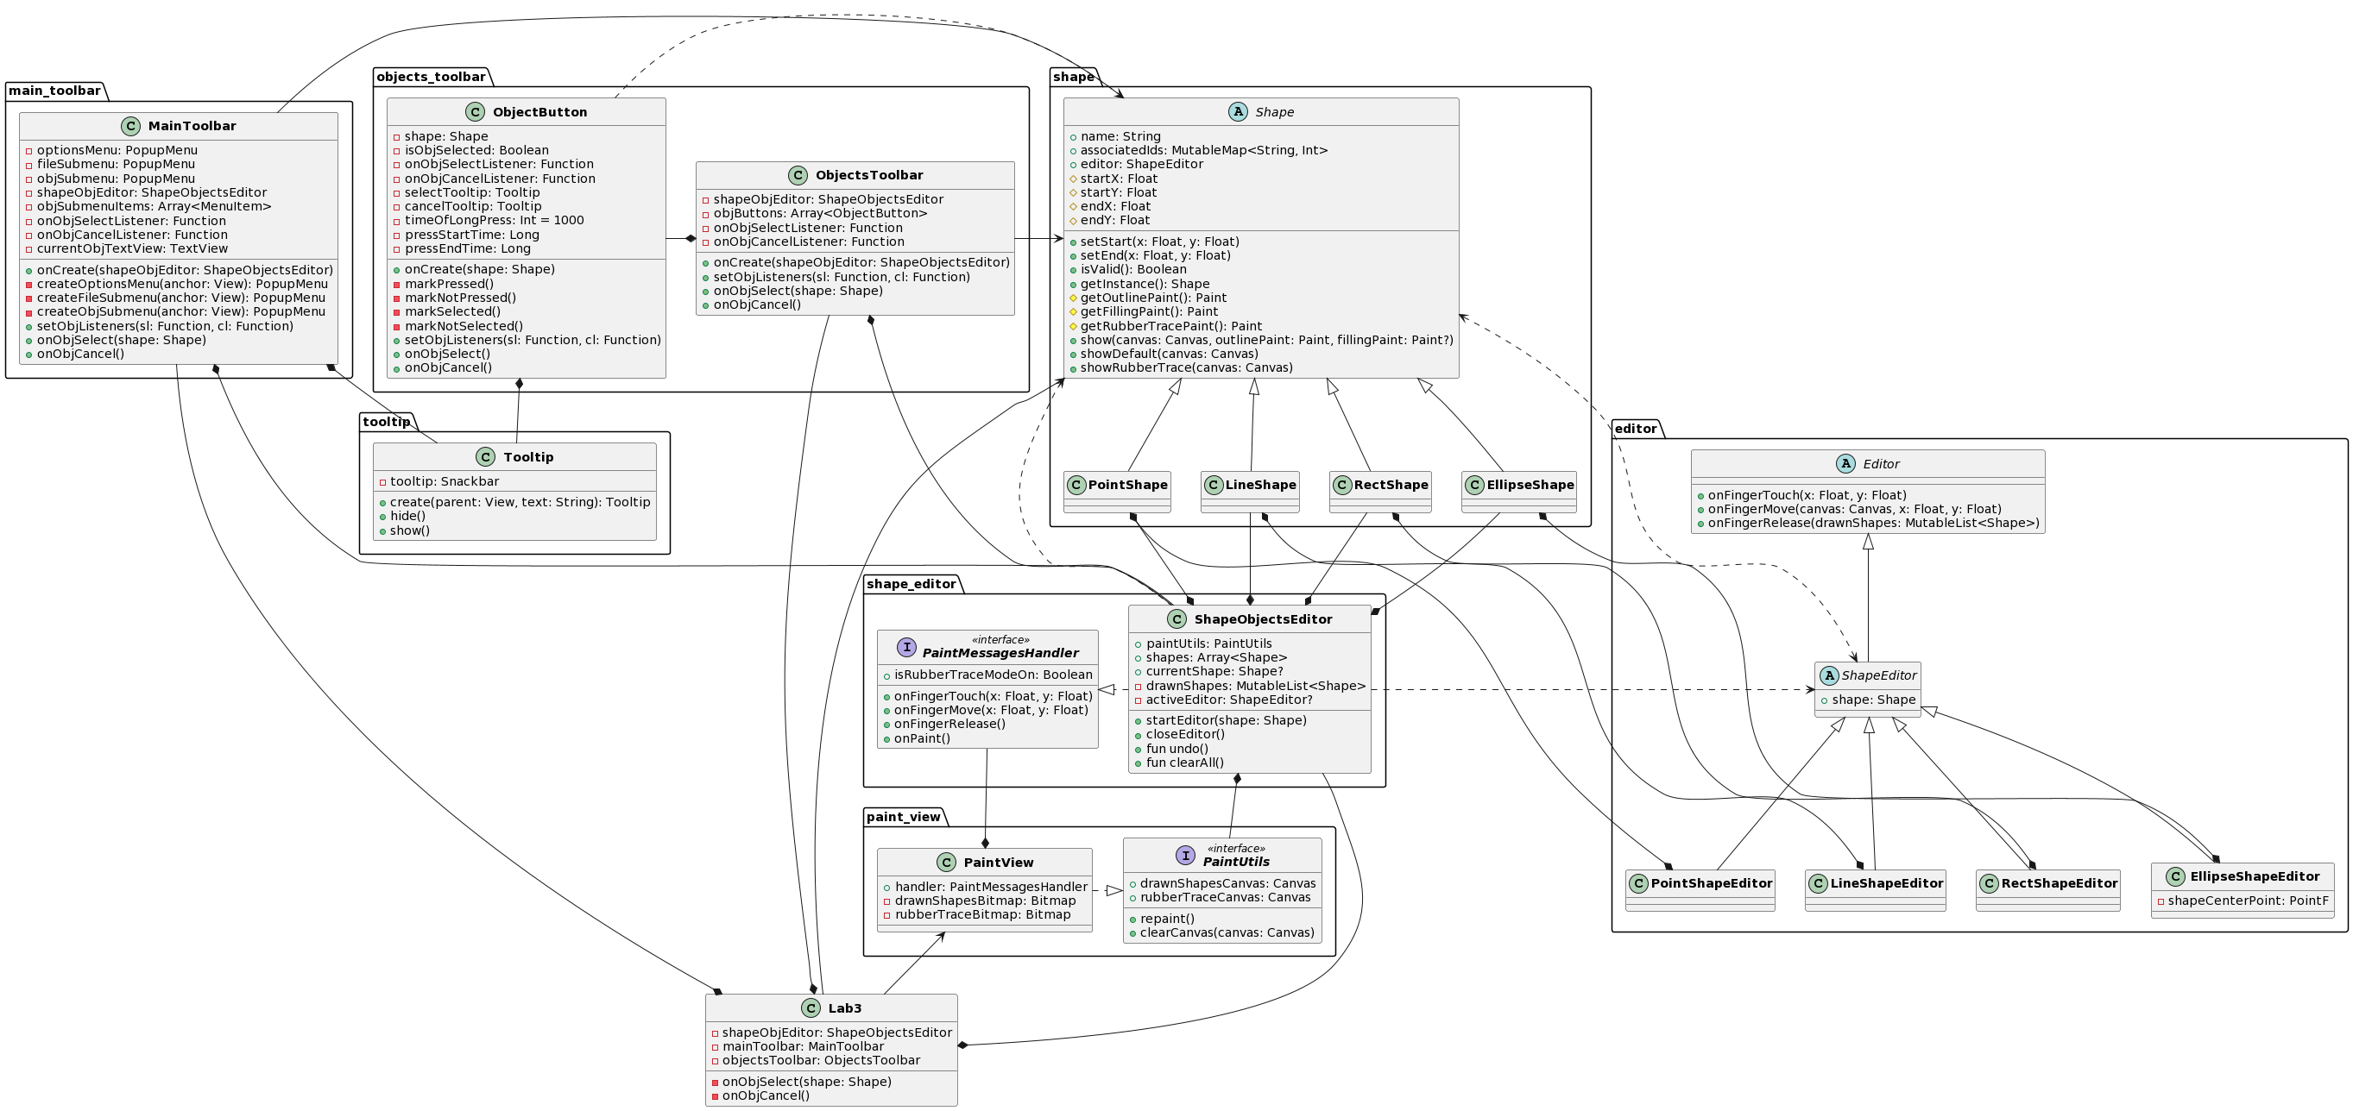

**Ілюстрації виконання програми**

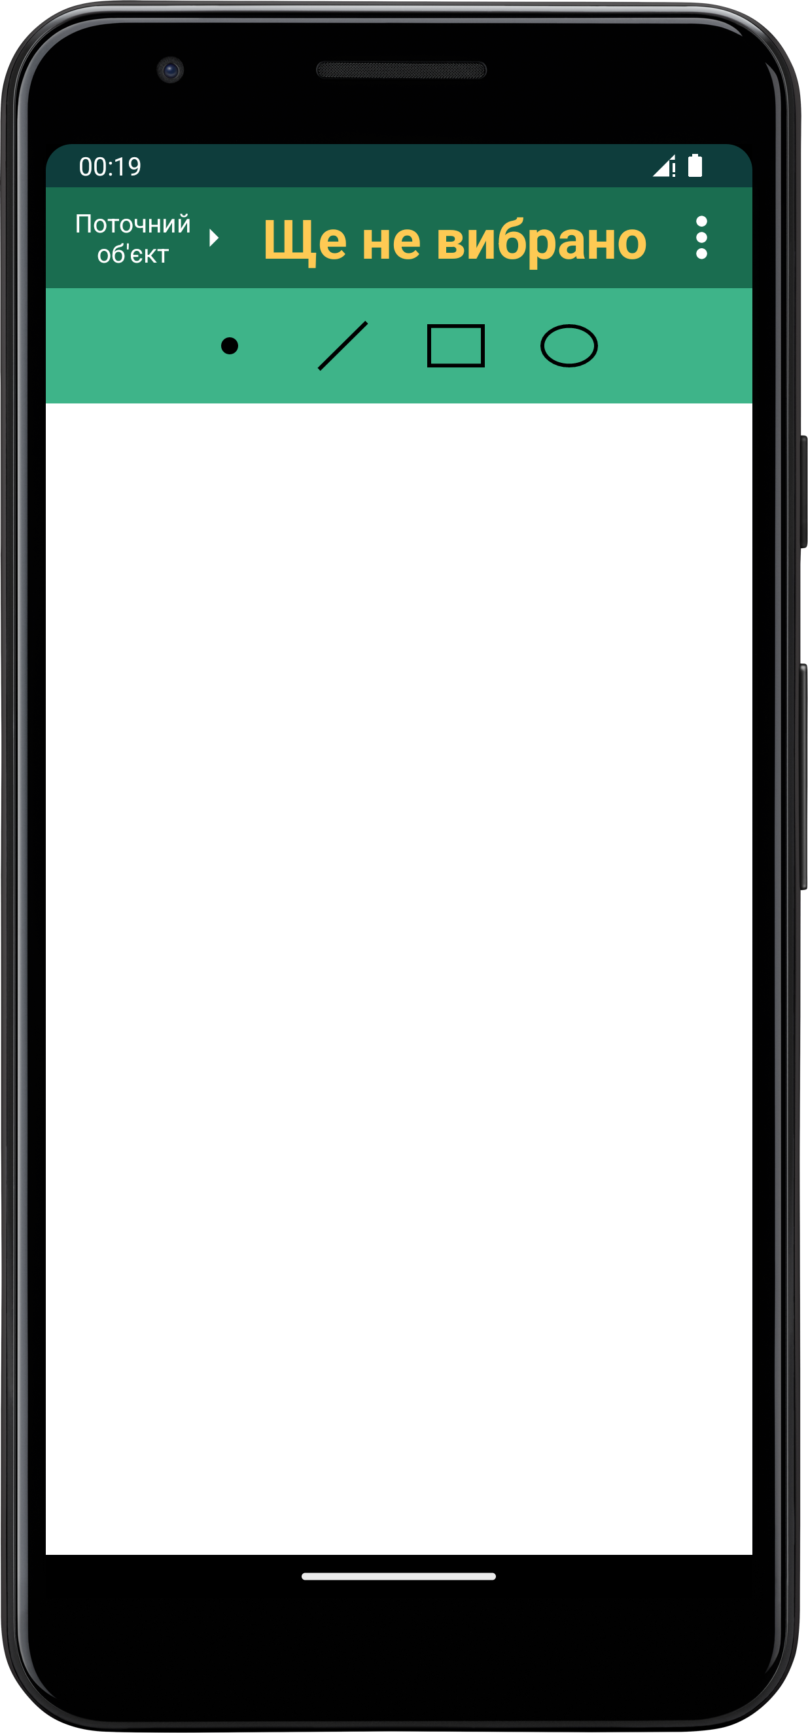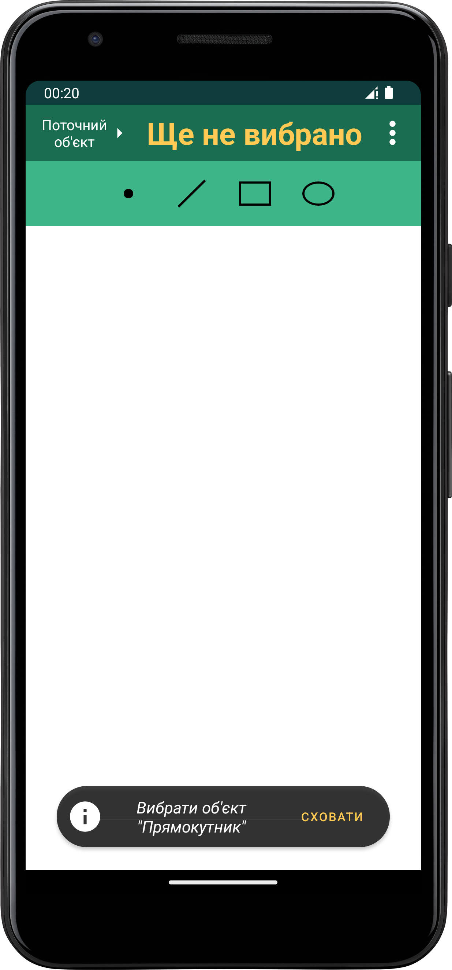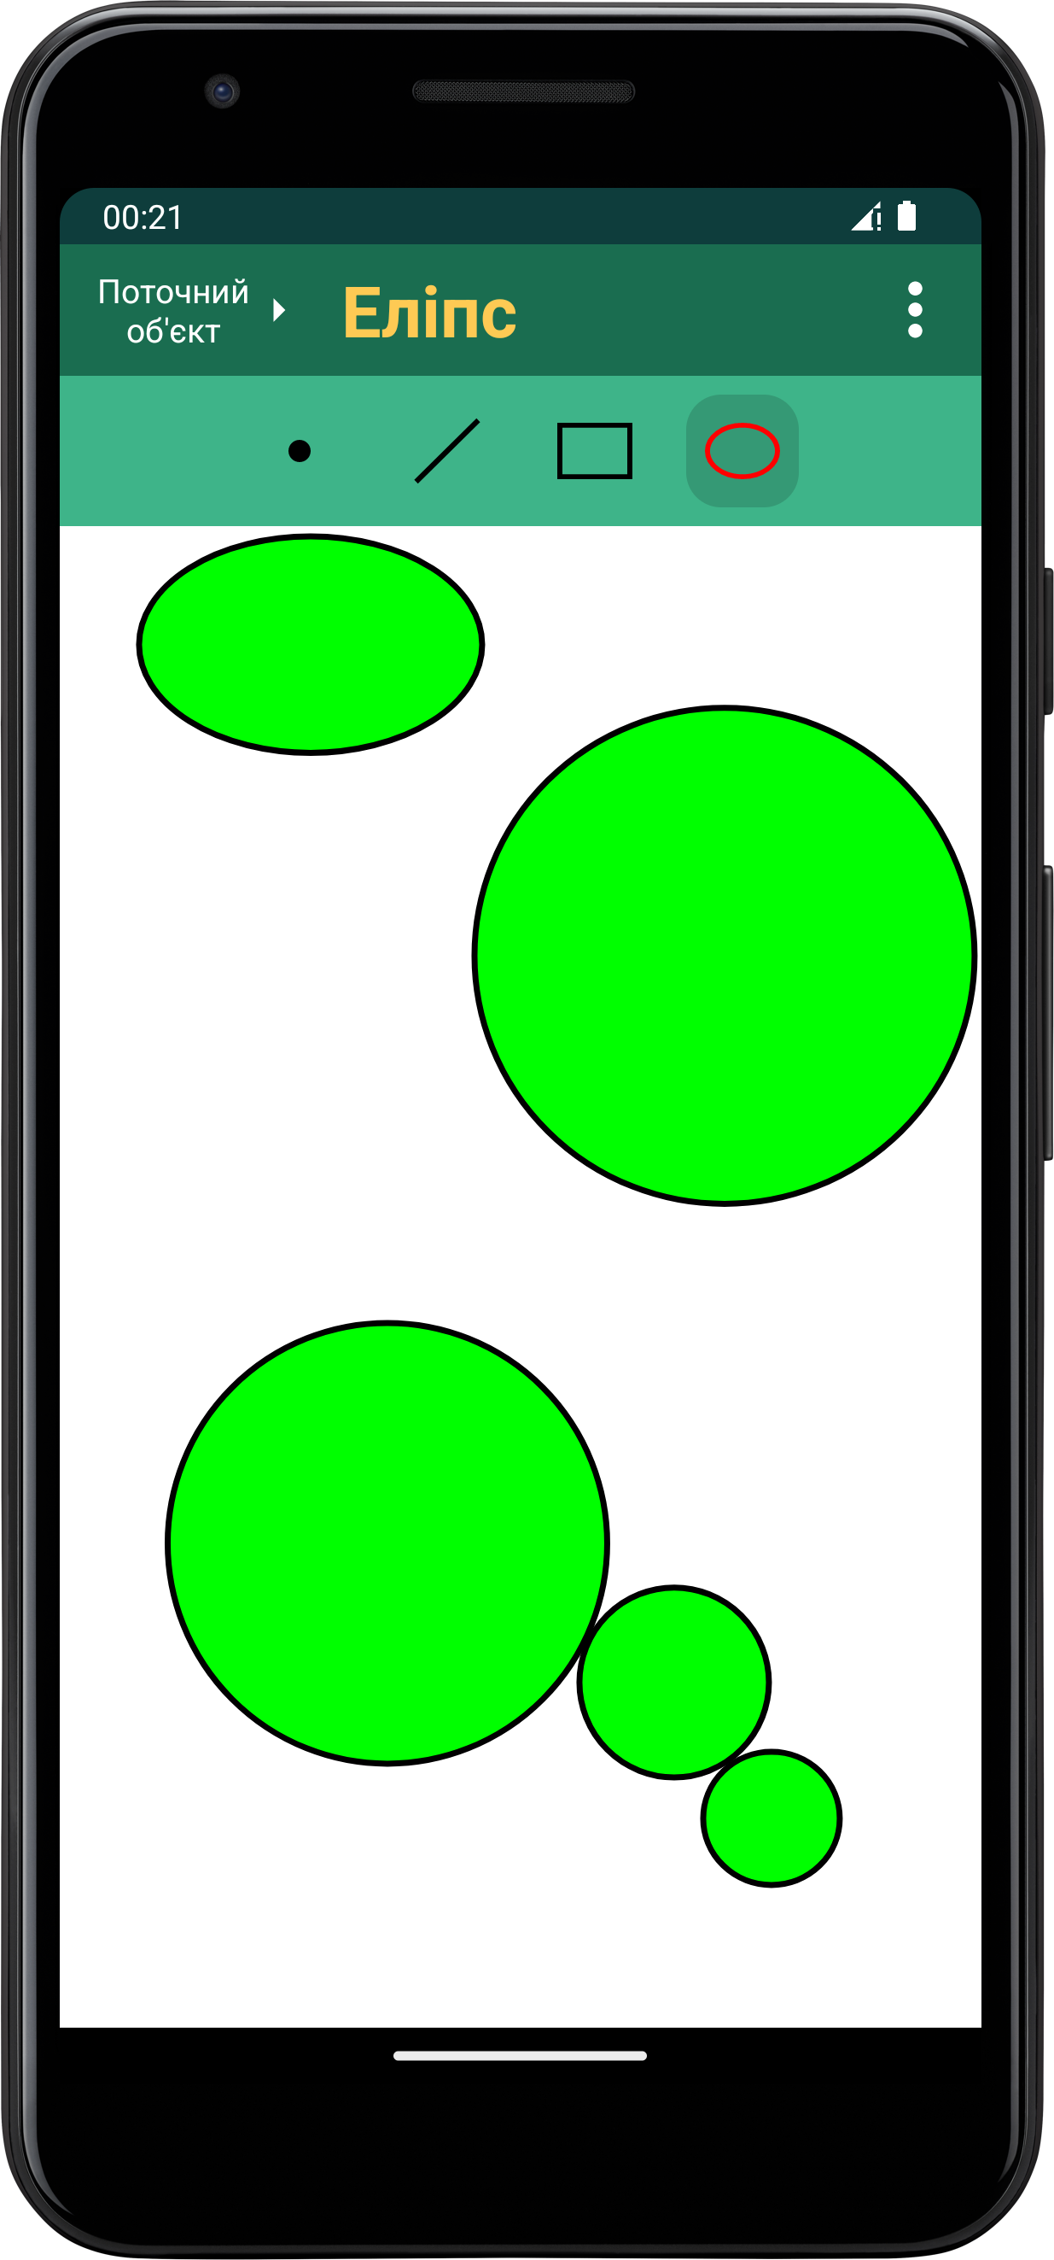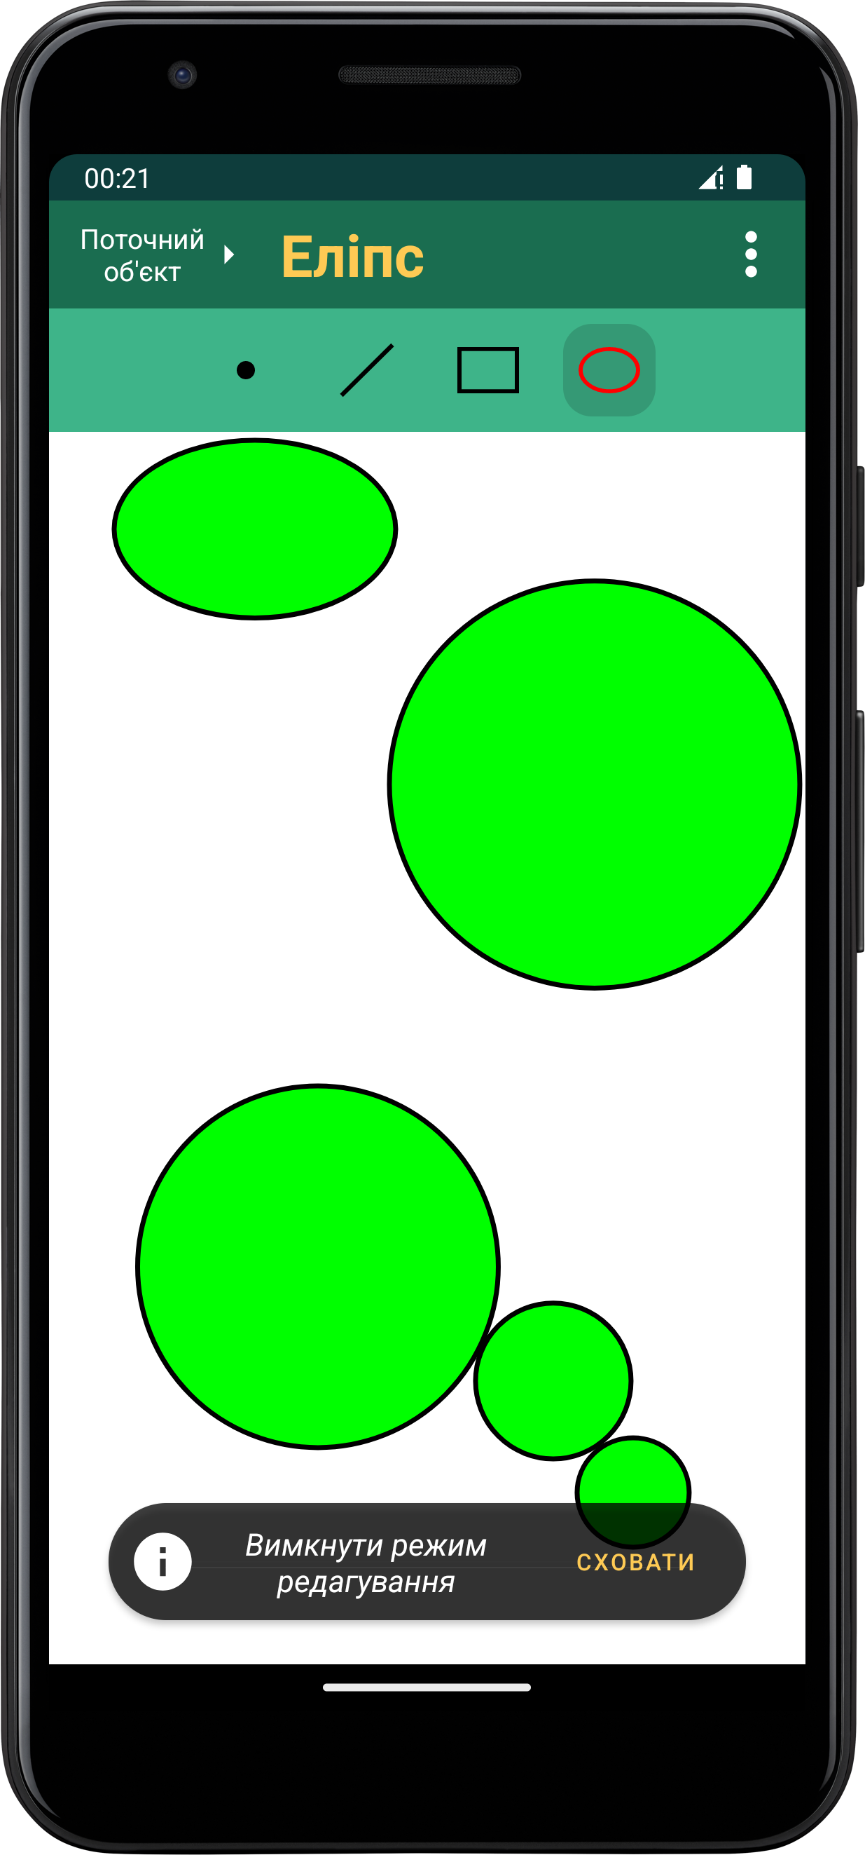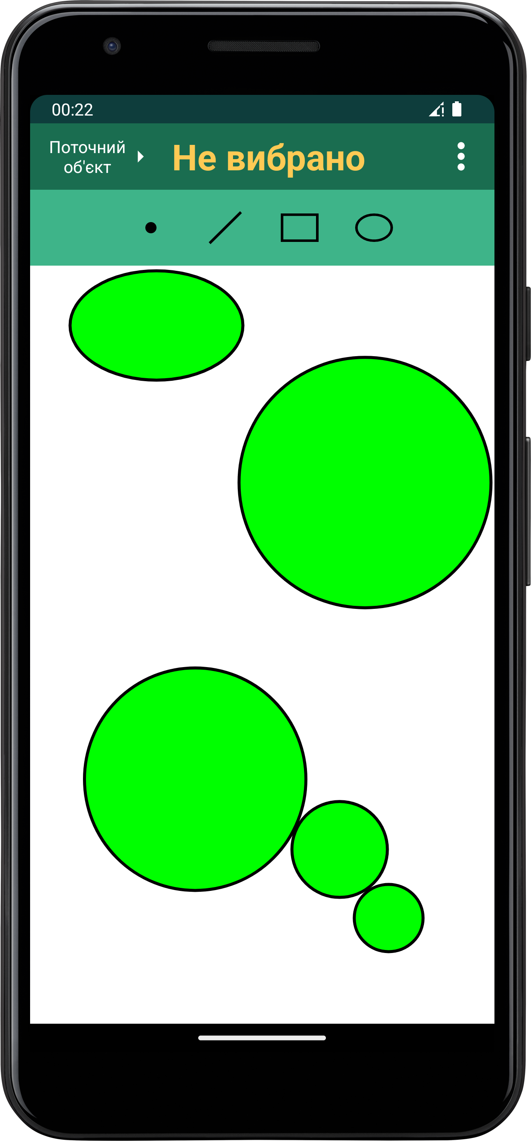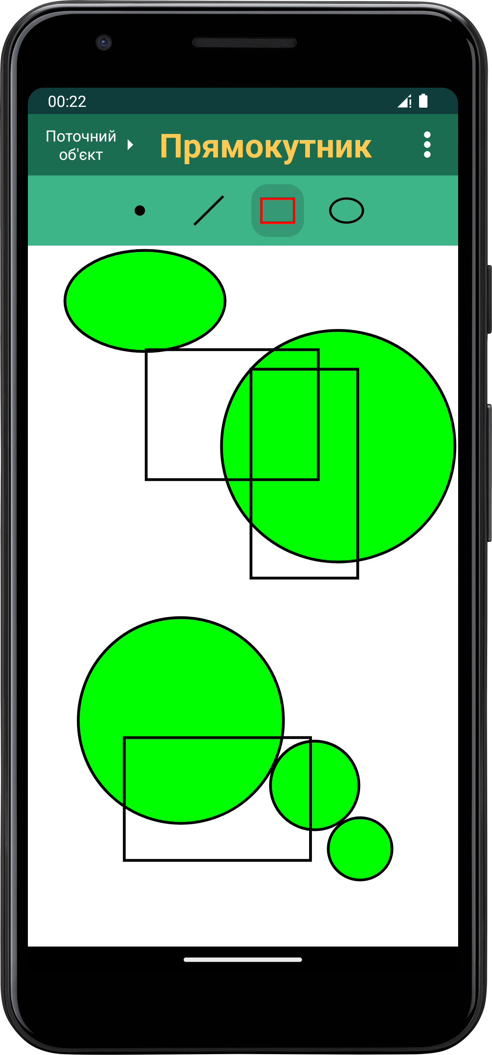

**Висновки**

Ця лабораторна робота допомогла мені навчитися використовувати інкапсуляцію, абстракцію типів, успадкування та поліморфізм на основі класів мови програмування ***Kotlin***. Я запрограмував простий графічний інтерфейс користувача в об’єктно-орієнтованому стилі, Він дозволяє зручно застосовувати основні можливості графічного редактора для платформи ***Android***, створеного у ході виконання 2-ї лабораторної роботи.